Cynthia Cho
Assignment 4
Due date: November 7, 2017

- Using the messaging.sql database (posted in with this assignment), write the following SQL queries.

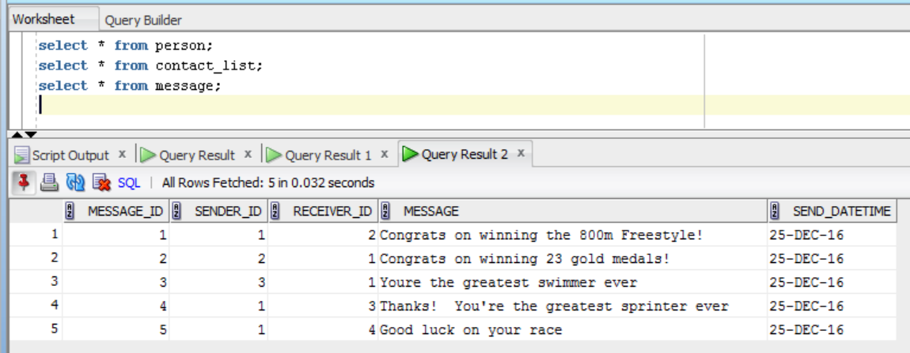

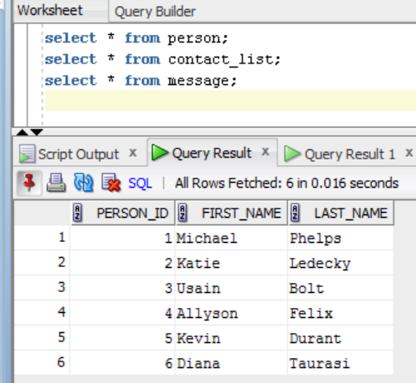

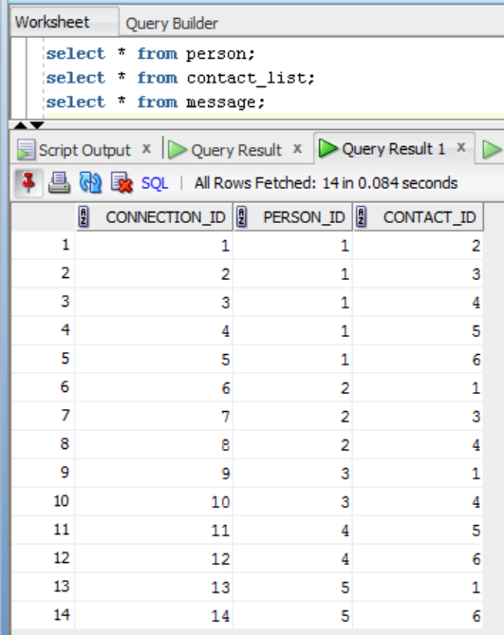
- Add yourself as a new record in the “person” table. Use your first name and last name for one of the new records that you are inserting.

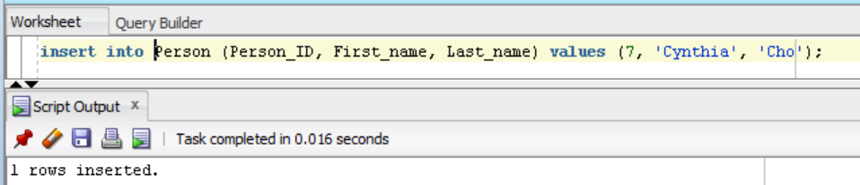

- Alter the Person table by adding a new property of your choice with the data type of your choice.
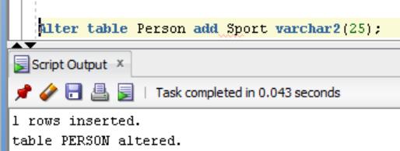

- Update your record in the Person table by setting some value to your new property.

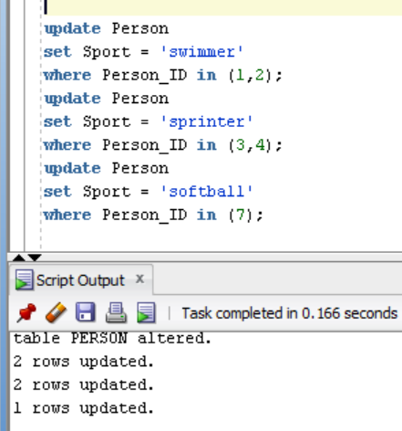

- Delete the Diana Taurasi record.

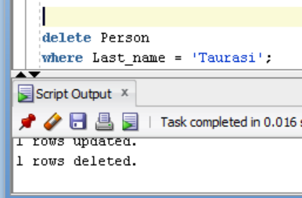

- Alter the Contact List table and add column for Favorite

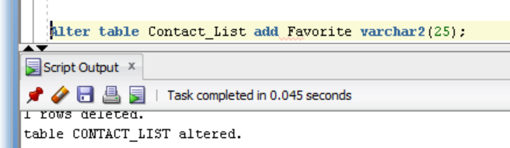

- Update the existing records in the “contact_list” table to use the new column that you created. Update the records in the table by setting Michael Phelps as everyone's favorite contact (contact_id = 1). The value for the “favorite” column should be set to “y” for these records.
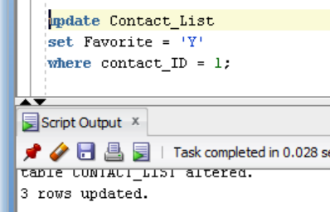

- Update the existing records in the “contact_list” table to use the new column that you created. Update the remaining record(s) in the table by setting every contact who is NOT Michael Phelps (contact_id <> 1) to not be a favorite. The value for the “favorite” column should be set to “n” for these records

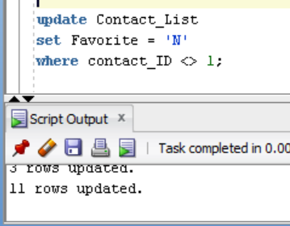

- Insert at least 3 new records in the “contact_list” table. Note: You are required to add at least 3 new records with yourself as a new contact in the “contact_list” table. Make sure that you provide a value (y or n) for the new “favorite” column.

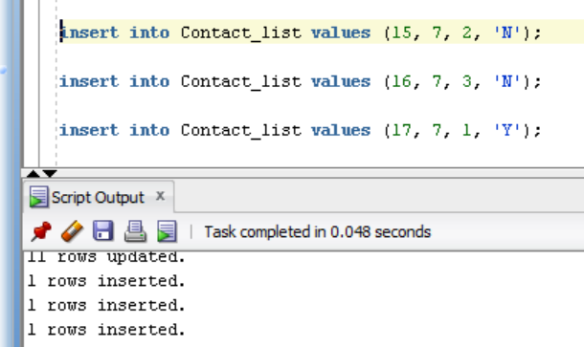

- Create a new table image with columns (image_id, image_name, image_location). Image_id is the primary key
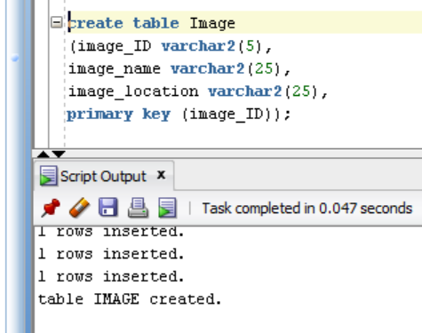

- Create a message-image table with columns (image_id,message_id). Image_id and message_id are the primary keys.
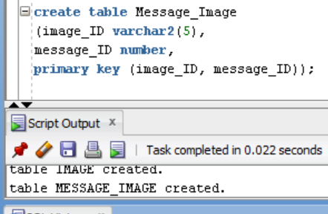

- Insert 5 new records in the “image” table.

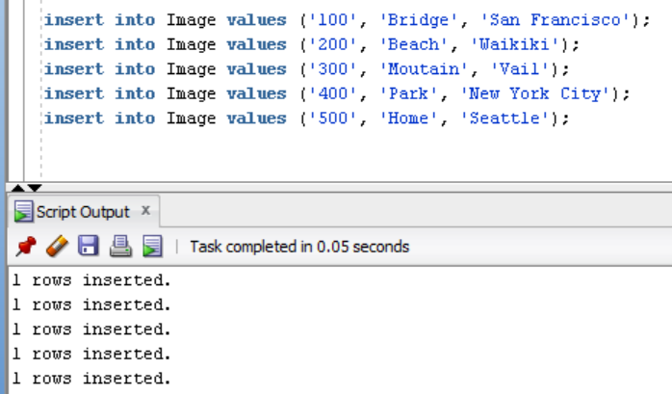

- Insert 5 new records in the “message-image” table.
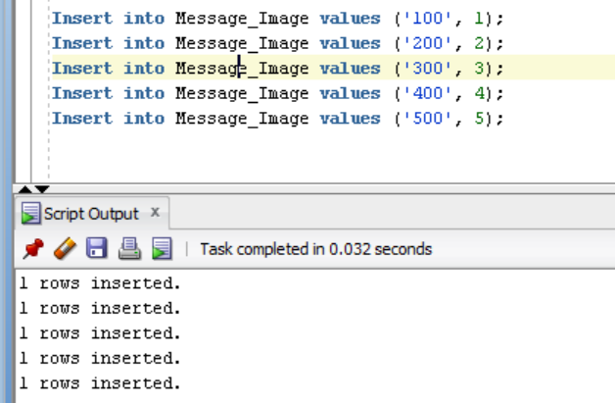

- Find All of the Messages that Michael Phelps Sent. Display the following columns
  - Sender's first name (Person)
  - Sender's last name (Person)
  - Receiver's first name (Person)
  - Receiver's last name (Person)
  - Message ID (Message)
  - Message (Message)
  - Message Timestamp (Message)

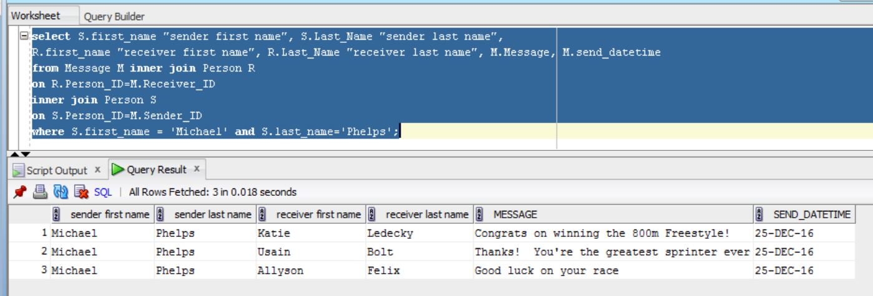

- Find the Number of Messages Sent for Every Person. Display the following columns
  - - Count of messages –
  - Person ID
  - First Name
  - Last Name

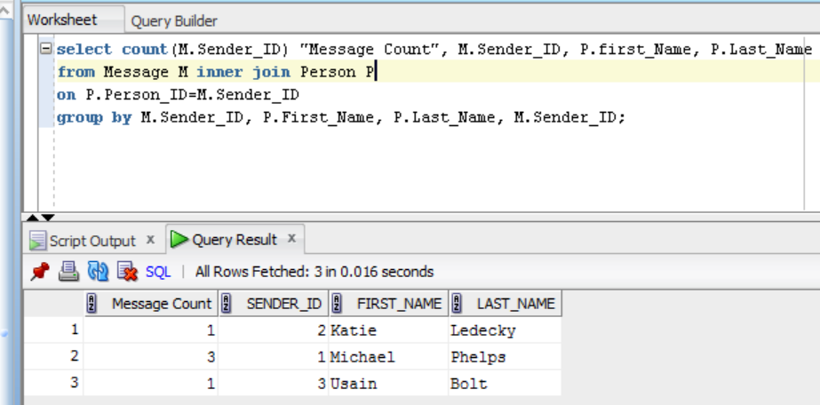

- Find All of the Messages that Have At Least One Image Attached Using INNER JOINs. Display the following columns:
  - Message ID
  - Message
  - Message Timestamp
  - First Image Name
  - First Image Location

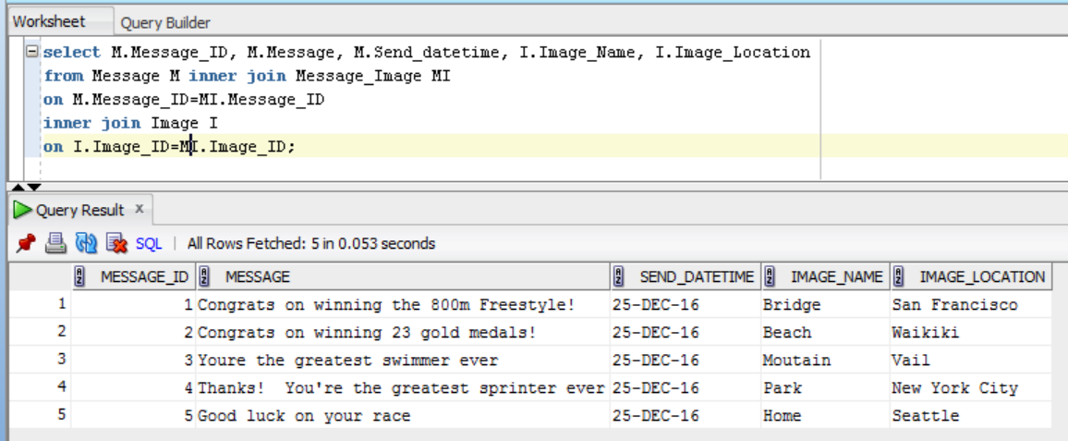

- Using the company.sql database (posted in with this assignment), write the following SQL queries.

- Find the names of all employees who are directly supervised by 'Franklin T Wong'
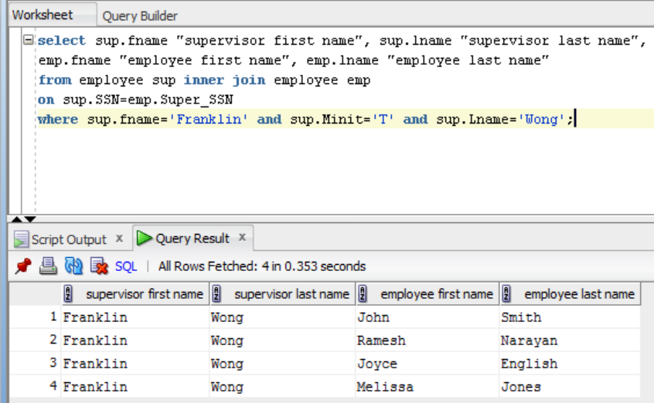

- For each project, list the project name, project number, and the total hours per week (by all employees) spent on that project.

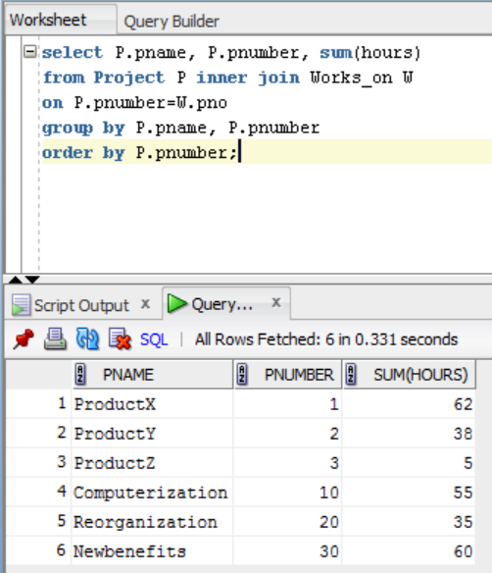

3. For each department, retrieve the department name and the average salary of all employees working in that department. Order the output by department number in ascending order.

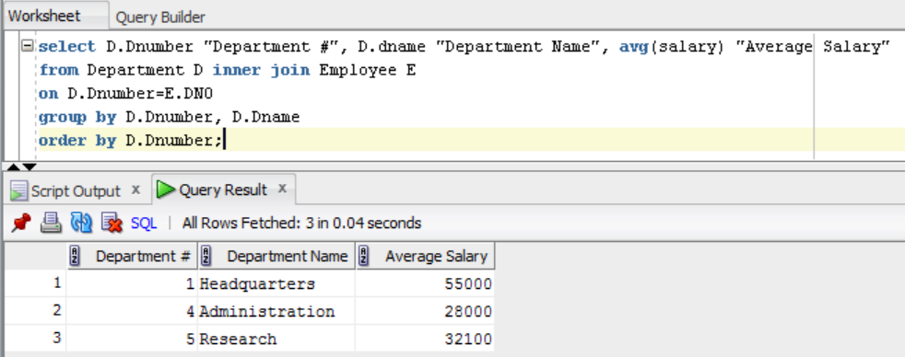

4. Retrieve the average salary of all female employees.
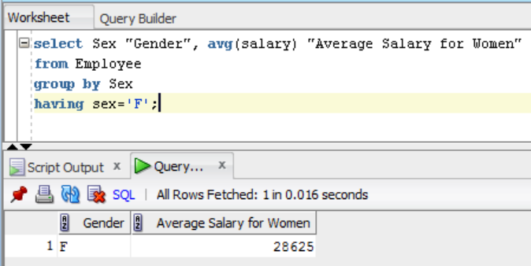

5. For each department whose average salary is greater than $44,000, retrieve the department name and the number of employees in that department.

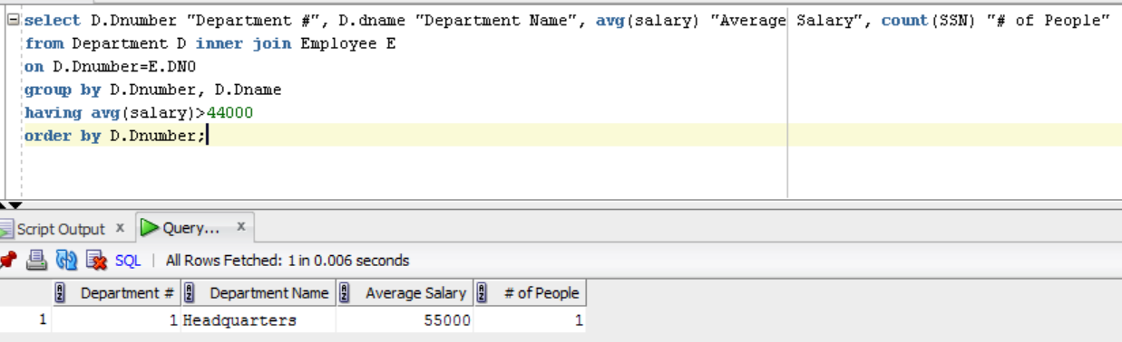

6. Retrieve the names of employees whose salary is within $23,000 of the salary of the employee who is paid the most in the company (e.g., if the highest salary in the company is $83,000, retrieve the names of all employees that make at least $60,000.).

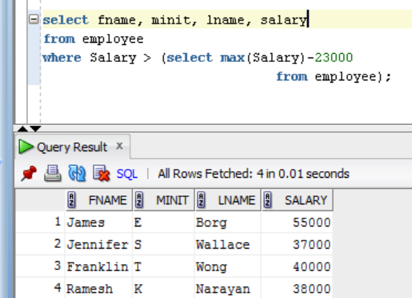

Be sure that your name and “Assignment 4” appear at the top of your submitted file.

